**Republika ng Pilipinas Lalawigan ng Bulacan Bayan ng Bulakan**

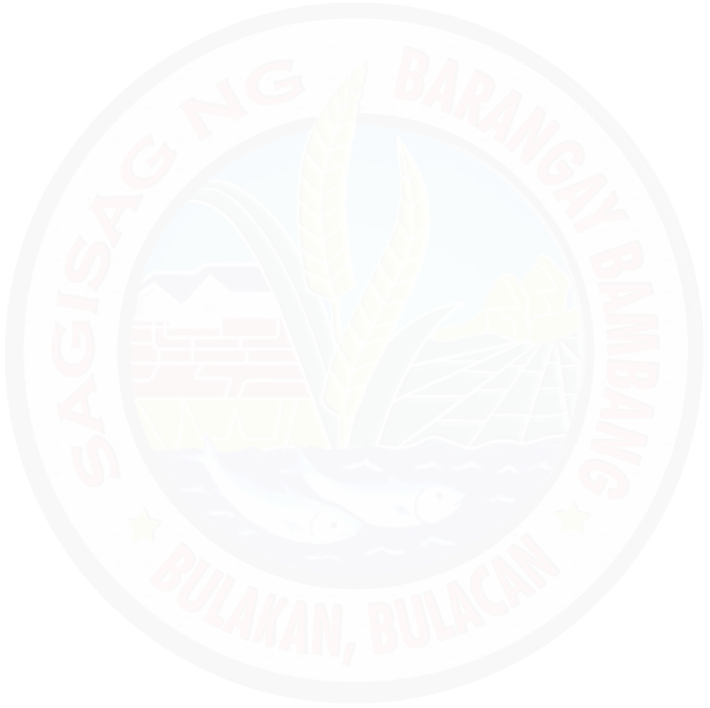

**BARANGAY BAMBANG**

**TANGGAPAN NG PUNONG BARANGAY**

# {date}

Certificate of Indigency

# TO WHOM IT MAY CONCERN:

This is to certify that, **{name}** resident of {address} Barangay Bambang Bulakan, Bulacan, and is one of many indigents of this locality.

{reason}

This certification is issued upon the request of the above-named person for whatever intents and purposes it may serve him/her so that he/she can avail of:

({education}) **Educational Assistance**

({burial}) **Burial Assistance**

({others}) **Others**

({medical}) **Medical Assistance**

({financial}) **Financial Assistance**

Issued this {dayNum} day of {month}, {year} at Barangay Bambang Bulakan, Bulacan.

**CTC No. 27813153**

**Issued on: {dateNum}**

**Issued at Bulakan, Bulacan**

**Resibo blg 4003314**

**Halaga: P{price}.00 Petsa: {dateNum}**

<https://www.facebook.com/MGALAKISABAMBANGBULAKANBULACAN>

# JOSE NARCISO C. ROQUE

**Punong Baranggay**

Purok 1, Bambang, Bulakan, Bulacan 813-1243